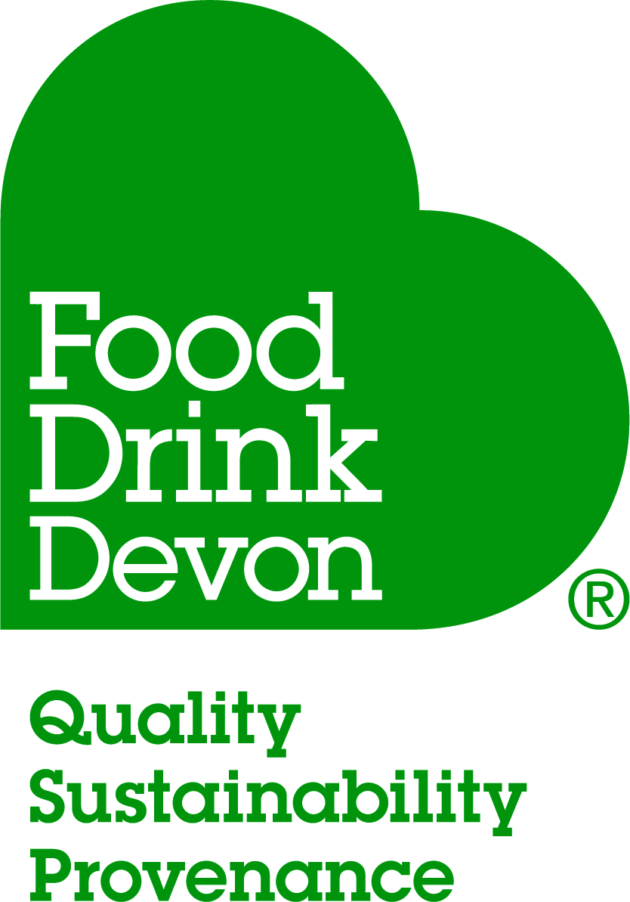

Food Drink Devon Awards 2022
Chef of the Year

Introduction

Food Drink Devon is a not for profit, dedicated membership organisation which promotes and supports Devon’s food and drink sector. Our 340 strong Devon-based membership (which includes cookery schools, hospitality and catering businesses, speciality retailers, farmers markets and producers) showcase Devon as a county where the use of fantastic quality, seasonal and local produce is standard. Our passion is for Devon’s exceptional food and drink to be enjoyed globally.

Our gold standard awards, now in their 11th year, celebrate the very best Devon has to offer by recognising and championing the county’s most respected, influential and passionate artisan food and drink producers and establishments.

The Chef of the Year competition, in its inaugural year, has been introduced to our awards scheme to provide Chefs with an opportunity to gain recognition for their dedication and ability and to raise their profile.

The competition aims to find and recognise highly skilled and enthusiastic chefs who can demonstrate their skills and imagination in preparing a meal using and celebrating the wide array of Devon’s quality produce.

The Competition
The Chef of the Year competition is open to any Head Chef or Sous Chef who lives and works in Devon.

Entrants are asked to devise a menu for a 3-course meal (starter, main and dessert) for 4 people using produce from Devon which must make up at least 70% of the total ingredients used.

To enter we will need a completed entry form and fee, full recipes and images for each course together with a list of all the ingredients used with the producer’s name and town written alongside. These must be received by the entry closing date of 22nd April 2022.

Judging
The judging will take place over two rounds with the judges looking for menus that are seasonal and celebrate and showcase Devon’s wonderful produce.

Round one - the paper judging, will take place in May where an unbiased expert judging panel will review and judge all entrants with an independent adjudicator verifying the results.

Round two - the top 4 contestants will then be invited to a final in June where they will be asked to prepare and serve their 3 course meal in 90 minutes. You will need to bring all your ingredients with you which must be in an unprepared state, we will allow a homemade stock. You will also need to bring any specialist equipment and presentation dishes that you may need. All entrants participate in the cook off at their own risk.

The winners will be announced at our glittering Awards Ceremony on Monday 3rd October 2022.

For all queries and entry forms please contact Ali Neagle on 07789 666064 admin@fooddrinkdevon.co.uk

